

**How to Maintain Nutritional Needs**

**Food Shopping**

* There is no need to stockpile or buy more food than you normally would as the government has no plans to close supermarkets or other food selling venders.
* It is possible to visit the food shops whilst social distancing.
* Friends or family members may need to support you to obtain specific foods so you can continue to follow an advised diet

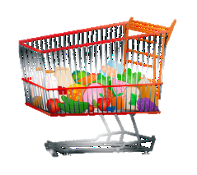

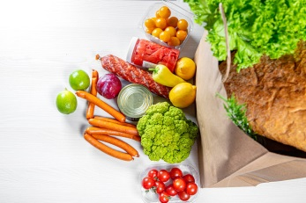

**Designated Shopping Hours & Delivery for the Vulnerable & Elderly**

* Tesco (not express stores) - 9am until 10am on a Monday, Wednesday and Friday
* Asda – 6am until 9am on Friday
* Sainsbury’s – 8am until 9am on a Monday, Wednesday and Friday
* Iceland – first hour of trading
* Lidl – first hour of trading
* M&S – first hour of trading on Mondays and Thursdays
* Morrison’s – 9am until 10am on Monday to Saturday

**Please pay by card where possible and maintain social distancing**

All of the big supermarkets offer a delivery service so can deliver all your shopping to your door. These services are currently extremely busy, so plan ahead and book a slot. Some of these services are also prioritising delivery for those most vulnerable and the elderly.

**Making the Most of Food**

* Use up fresh ingredients/foods with a shorter shelf life first so food doesn’t go to waste.
* Make sure items aren’t stored in the fridge that don’t need to be in there, e.g. fresh tomatoes, un-peeled onions, un-peeled jacket potatoes, don’t need to be stored in the refrigerator.
* If possible, remove packaging, making note of the use by date to allow for more space in the fridge.
* During the ‘stay at home’ period, take the opportunity to declutter the kitchen cupboards to free up space for food products.
* Have a few easy to cook and pre-prepared foods in the house on standby if needed, e.g. canned soups, microwavable rice and frozen ready meals are easy options that you can keep in stock in reasonable quantities



**Supporting Those at Risk of Malnutrition**

* Can they access supermarkets and food outlets to purchase food and drink or have they been asked to remain at home?
* Do they have enough food and drink in their house to meet their nutritional needs until the next time a shopping trip is made?
* Do they have access to ingredients that can be used to increase the nutrient content of meals (see additional sheet) and fluid if they are at risk of malnutrition?
* Do they have a store cupboard of non-perishable basic foods, pre-prepared and/or frozen meals?
* Can they be linked to local social prescribing or adult social care teams via their local council?
* Can they access meal home delivery services such as Wiltshire Farm Foods, Oakhouse Foods or Hamilton meals?
* Can they maintain communication by telephone and other technologies ie Skype/WhatsApp etc to reduce social isolation?

Please note:

* Oral nutritional supplements (ONS) will only be considered where clinically indicated, of which do not include food access issues.



**Self-Isolation**

Doncaster Community Connect is a partnership of organisations aimed at supporting the most vulnerable people in the community to deal with urgent and ongoing needs particularly during the Covid-19 outbreak. They can help with things like:

**Picking up shopping & supplies**

**Providing meals**

**Picking up medicines**

**Supporting you to keep active**

**Helping you keep connected**

**Posting mail**

Get in touch for more information and support:

**Telephone: 01302 430300**

**Email:** [**enquiries@dncommunityhub.org.uk**](mailto:enquiries@dncommunityhub.org.uk)

**Website: www.dncommunityhub.org.uk**

**Contact Details**

Rotherham Doncaster and South Humber NHS Foundation Trust Dietitians - Tel: 01302 796410 Email: rdash.dietetics@nhs.net

Doncaster and Bassetlaw Teaching Hospitals NHS Foundation Trust Dietitians

Tel: (Doncaster): 01302 642742 (Bassetlaw): 01909 572773 Email: dbh-tr.dietetics@nhs.net